**Cairo University  
Faculty of Computers and Information** 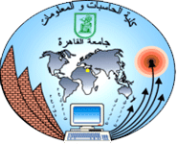

**CS251**

**Software Engineering I**

Kangae (考え)

Software Design

Maryam El-Sokkary

Omar Mohamed

Khadega Osman

Marwa saied

DEC 2016

**Contents**

Team

Document Purpose and Audience

System Models

I. Class diagrams

Important Algorithm

II. Sequence diagrams

Class - Sequence Usage Table

Ownership Report

Policy Regarding Plagiarism:

References

Authors

# Team

|  |  |  |  |
| --- | --- | --- | --- |
| **ID** | **Name** | **Email** | **Mobile** |
| 20140110 | Khadega Osman Ahmed | khadiga.osman16@gmail.com | 01009973673 |
| 20140261 | Marwa Saied Mohamed | marwasaied18@gmail.com | 01003340819 |
| 20140264 | Maryam Ashraf El-sokkry | maryam.sokkary@gmail.com | 01111087009 |
| 20130327 | Omar Mohamed | o-mohamed@hotmail.com | 01114575041 |

# Document Purpose and Audience

* Document purpose to explain everything how the implementation will look like in the class diagram and how the sequence of movement will work through the sequence diagram
* the audience will be the teacher assistant who is responsible of our project.

# [Github](https://github.com/Omaar22/kangae-)

# System Models

## I. Class diagrams

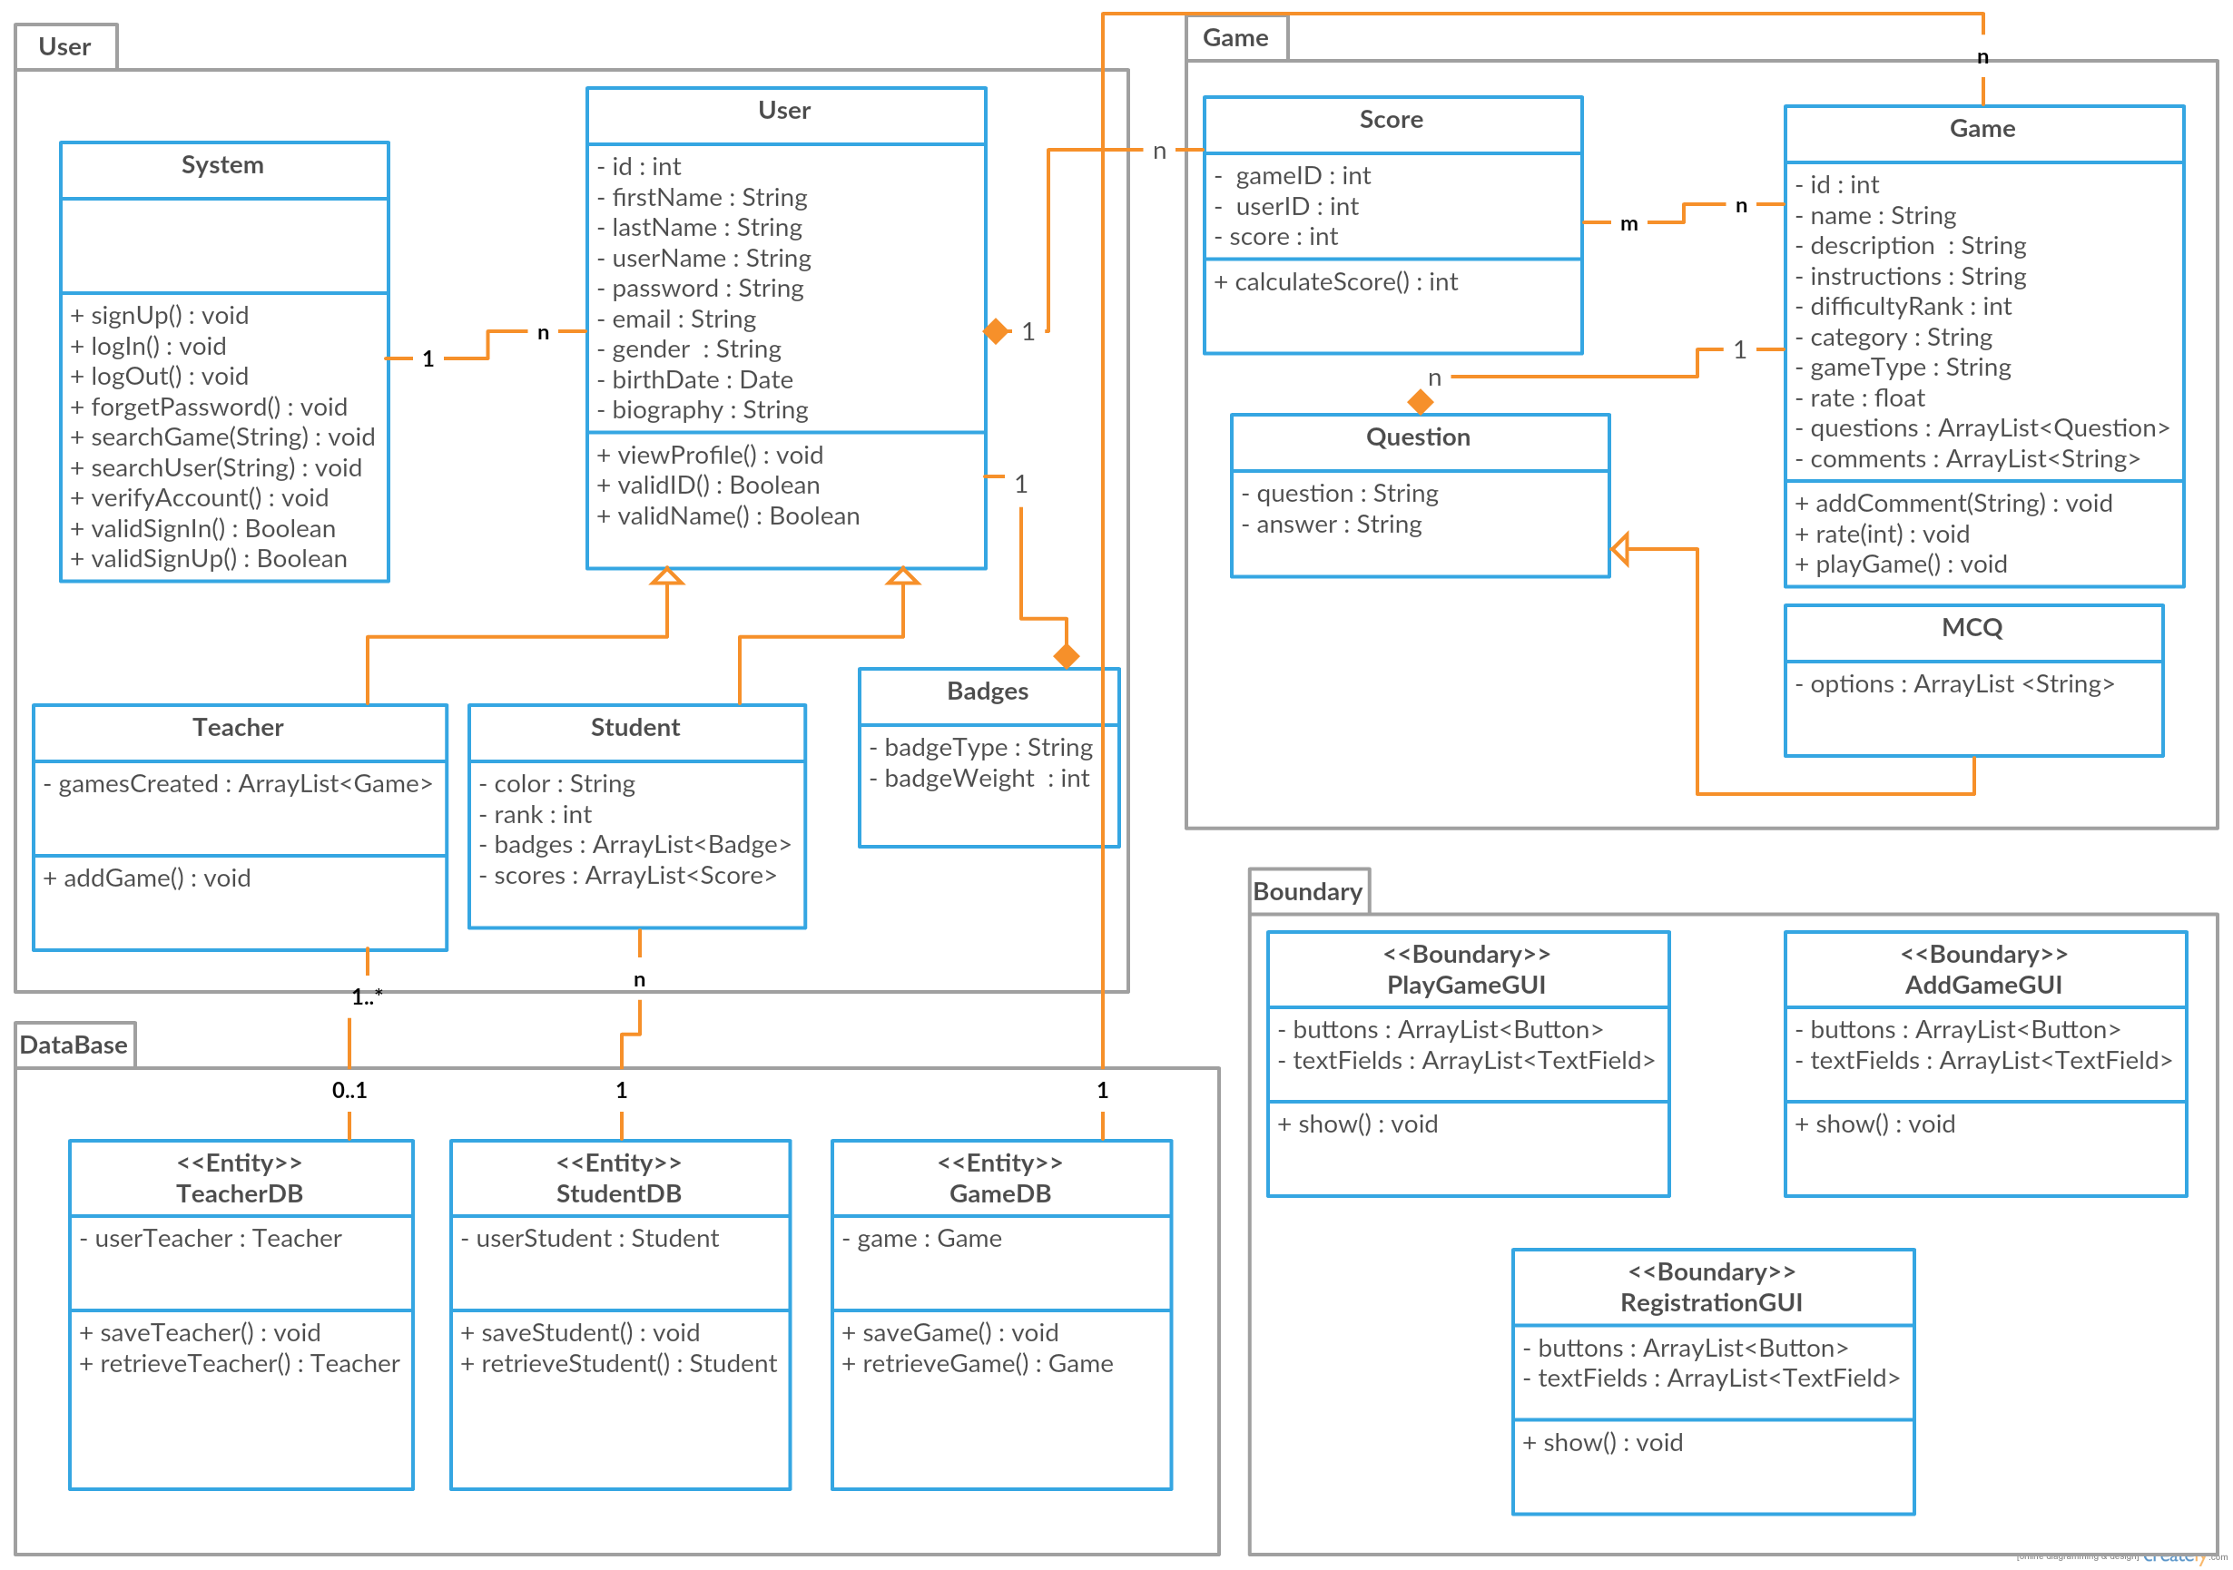

|  |  |  |
| --- | --- | --- |
| **Class ID** | **Class Name** | **Description & Responsibility** |
| 1 | User | Contains the following data for a user for his/her profile:   * Username * First name * Last name * ID * Gender * Birthdate * Password * Biography   Responsible for setting data of the user and displaying it |
| 2 | Student | Contains additional and specific data for the student:   * Color each user has a color according to his/her ranking * Rank user rank in the website * Badges list of badges that the user earned * Scores list of each game’s score he played   Responsible for assigning user a color, badges, scores, rank and displaying them |
| 3 | Teacher | Responsible for:   * Creating game ,giving it a description * Setting instruction to each game and ranking it * Editing or deleting * Has an authority to reply to comments in games which is created by him |
| 4 | System | Responsible for all interactions made in the website:   * Signing up * Signing in * Logging out * Searching for a game * Searching for a user * Account verification |
| 5 | Badges | contains badge type and weight  responsible for making a new badge for new achievements |
| 6 | Game | Contains the following data for each game:   * ID * Name * Description * Instruction * Difficulty rank * Category * List of Questions * Number of question * List of answers * Rate   Responsible for checking the validation of name and id for each game ,setting a new game and a rate into database |
| 7 | Question | Has a question and its answer  responsible for assigning and retrieving a question and its answer |
| 8 | MCQ | Has all options that user can choose from and contains only one right answer  responsible for assigning and retrieving options for a question |
| 9 | Score | Has game ID, Use ID and a score  when user plays a game, object score is added and updated continuously when a user make high score |
| 10 | User database | Has all the user objects created in the system  responsible for adding a new user object, editing existing user object, getting existing user object and deleting it |
| 11 | Game database | Has all the game objects created in the system  responsible for adding a new game object, editing existing game, getting existing game object and deleting it |
| 12 | Question database | Has all the question objects created in the system  responsible for adding a new question object, editing existing question, getting existing question object and deleting it |
| 13 | Score database | Has all scores made for each user in the system  responsible for adding a new score object, editing existing score for a user in a specific game, getting existing score object and deleting it |
| 14 | Badges database | Has all badges given for every user in the system  responsible for adding a new badge for a user and getting it |

## II. Sequence diagramsSequence Diagram.png

## 

## 

## 

### 

### 

### Class - Sequence Usage Table

|  |  |  |
| --- | --- | --- |
| **Class Name** | **Sequence Diagrams** | **Overall used methods** |
| User | Registration sequence diagram | Sign up, |
| Student | Registration sequence diagram,play game sequence diagram |  |
| Teacher | Registration sequence diagram,add game sequence diagram |  |
| Game | Play game sequence diagram, add game sequence diagram | Setters and getters  add game , play game |
| Question | Play game sequence diagram, add game sequence diagram | Setters and getters |
| MCQ | Play game sequence diagram, add game sequence diagram | Setters and getters |
| Badges | Play game sequence diagram | Get badge |
| Score | Play game sequence diagram | Count score |
| teacher Database | Registration sequence diagram | Save user |
| student Database | Registration sequence diagram | Save user |
| Game database | add game database | Save game |

# Ownership Report

All team worked together in all functions/classes

# References

* http://www.mhhe.com/engcs/compsci/pressman/graphics/Pressman5sepa/common/cs1/design.pdf

# Authors

* Mostafa Saad and Mohammad El-Ramly (Edited by Mohamed Samir)